Pre 9.1

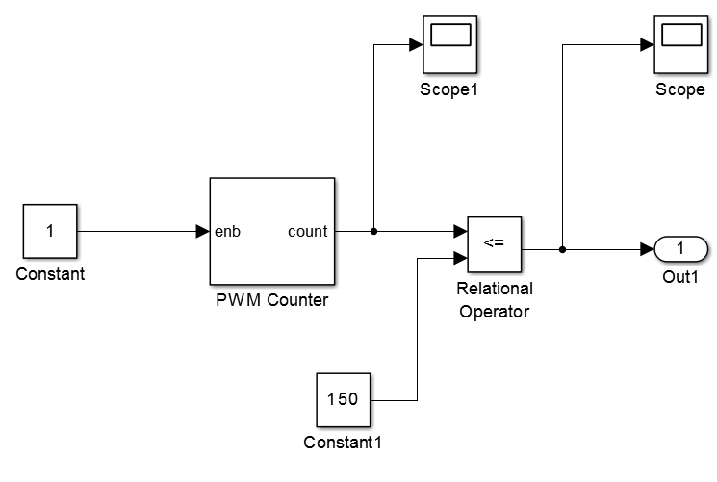

Pre 9.2

1. 600 usec
2. 1500 usec
3. 3300 usec

